Mohammed Al Madhi

CIS-310

Due: 9/29/2019

HW: 6

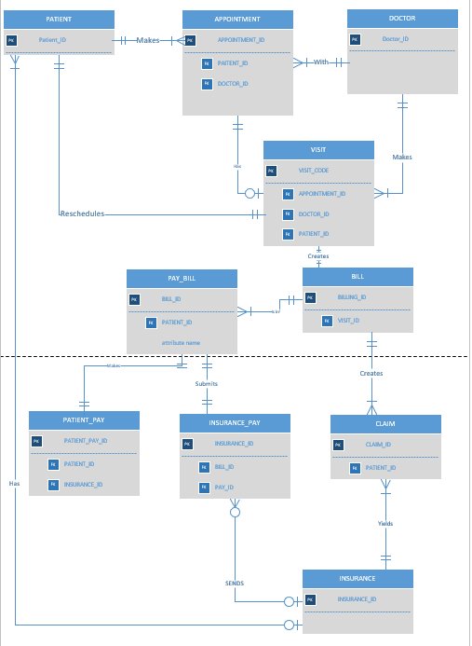

The Entities of ER Diagram are:

DOCTOR, APPOINTMENT, PATIENT, VISIT, PAY_BILL, BILL, PATIENT_PAY, INSURANCE_PAY, CLAIM, INSURANCE